Human Development Index (HDI) Prediction System – ER Diagram
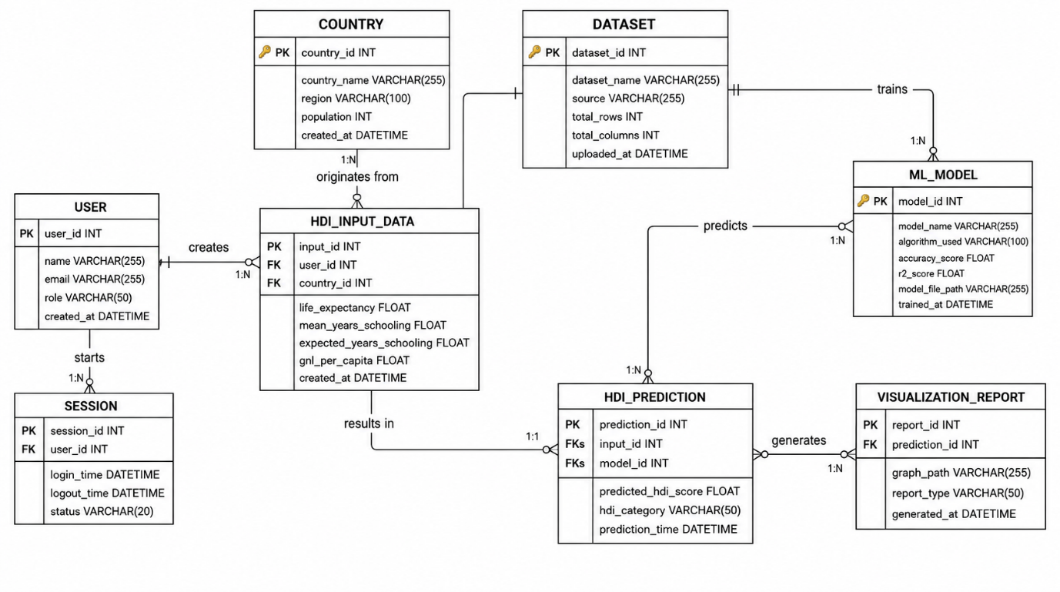
The Human Development Index (HDI) Prediction System is designed to predict the HDI score of different countries using Machine Learning. The system stores user information, country details, HDI input data, datasets used for training, trained machine learning models, prediction results, and generated visualization reports. The ER diagram illustrates the relationships among these entities.

The ER Diagram provides a structured representation of the HDI Prediction System database. It defines how users, countries, datasets, machine learning models, predictions, and visualization reports are interconnected. The design ensures data integrity through primary and foreign key relationships while supporting efficient storage, prediction, and reporting functionalities. This database structure forms the foundation for accurate HDI prediction and effective management of machine learning workflows.
Entities Involved
The ER diagram features eight primary entities:
- User
- Country
- HDI Input Data
- ML Model
- HDI Prediction
- Dataset
- Visualization Report
- Session
Primary Keys
- Each entity is uniquely identified by its primary key:
- User: user_id
- Country: country_id
- HDI Input Data: input_id
- ML Model: model_id
- HDI Prediction: prediction_id
- Dataset: dataset_id
- Visualization Report: report_id
- Session: session_id
Relationships
User to HDI Input Data: One user can submit multiple HDI prediction inputs (1 to Many).
- Country to HDI Input Data: One country can have multiple HDI input records for prediction analysis (1 to Many).
- HDI Input Data to HDI Prediction: A single input record generates one HDI prediction result (1 to 1).
- ML Model to HDI Prediction: One machine learning model can generate multiple HDI predictions (1 to Many).
- HDI Prediction to Visualization Report: One prediction can generate multiple reports and visualizations (1 to Many).
- Dataset to ML Model: One dataset can be used to train multiple machine learning models (1 to Many).
- User to Session: One user can have multiple application sessions (1 to Many).
User Attributes
- Attributes include:
- user_id (PK)
- name
- email
- role
- created_at

Conclusion
- The Entity Relationship (ER) Diagram provides a clear and structured representation of the database architecture for the Human Development Index (HDI) Prediction System. It defines the key entities, their attributes, and the relationships required to efficiently manage user information, country data, HDI input parameters, machine learning datasets, trained models, prediction results, and visualization reports.
- The use of primary keys and foreign keys ensures data integrity and establishes strong relationships among the database tables. The normalized database design minimizes data redundancy, improves consistency, and enhances the efficiency of data storage and retrieval. Furthermore, the database supports the complete workflow of the system, from user authentication and data entry to model training, HDI prediction, and report generation.
- Overall, the ER diagram serves as the foundation for implementing a reliable, scalable, and maintainable database. It enables seamless integration with machine learning models, supports accurate HDI prediction, and facilitates effective analysis through graphical reports. This well-designed database structure ensures that the HDI Prediction System operates efficiently while allowing future enhancements, such as the addition of new prediction models, datasets, and analytical features.

